Quadrilateral Pyramid
# Source: AI Source: Provided by: [Data Path: Persons Table -> ID Column: 1, Name_En Column: Motasem Essam] -> From: [ChatGPT] on [7/25/2026]
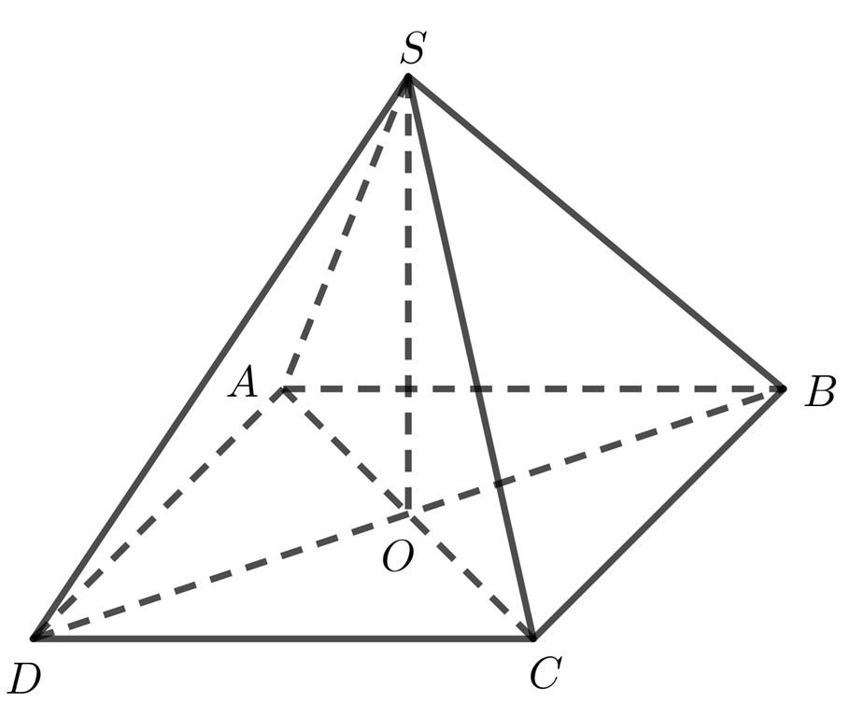
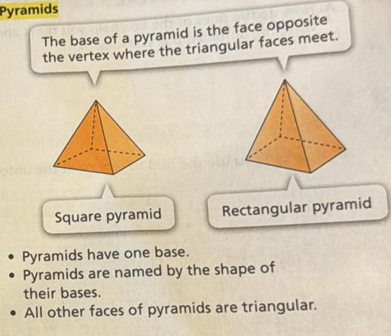
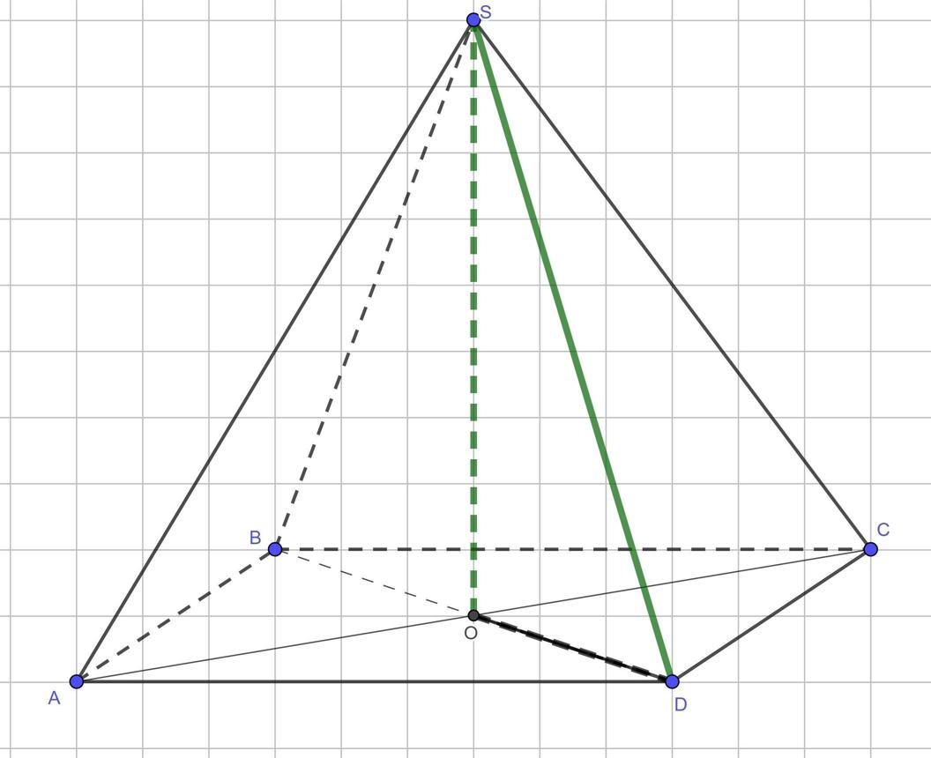

Definition
# Source: AI Source: Provided by: [Data Path: Persons Table -> ID Column: 1, Name_En Column: Motasem Essam] -> From: [ChatGPT] on [7/25/2026]
A quadrilateral pyramid is a three-dimensional polyhedron with one quadrilateral base and four triangular lateral faces that meet at a common vertex called the apex.
The base may be a square, rectangle, rhombus, parallelogram, trapezoid, or another type of quadrilateral.
A quadrilateral pyramid has 5 faces, 8 edges, and 5 vertices.
A square pyramid is a special type of quadrilateral pyramid whose base is a square.

Simple Definition
# Source: AI Source: Provided by: [Data Path: Persons Table -> ID Column: 1, Name_En Column: Motasem Essam] -> From: [ChatGPT] on [7/25/2026]
A quadrilateral pyramid is a solid that has:
- One four-sided polygon as its base.
- Four triangular side faces.
- One apex where the four side faces meet.
- Five faces, eight edges, and five vertices in total.
Unlike a quadrilateral prism, which has two parallel quadrilateral bases, a quadrilateral pyramid has only one base and tapers to an apex.

Classification Tree
# Source: AI Source: Provided by: [Data Path: Persons Table -> ID Column: 1, Name_En Column: Motasem Essam] -> From: [ChatGPT] on [7/25/2026]
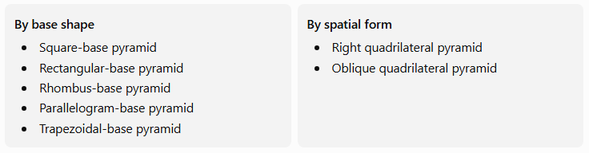
By base shape
- Square-base pyramid
- Rectangular-base pyramid
- Rhombus-base pyramid
- Parallelogram-base pyramid
- Trapezoidal-base pyramid
By spatial form
- Right quadrilateral pyramid
- Oblique quadrilateral pyramid
These classifications describe different features. For example, a square-base pyramid can be right or oblique, depending on the position of its apex relative to the base.

Key Characteristics
# Source: AI Source: Provided by: [Data Path: Persons Table -> ID Column: 1, Name_En Column: Motasem Essam] -> From: [ChatGPT] on [7/25/2026]
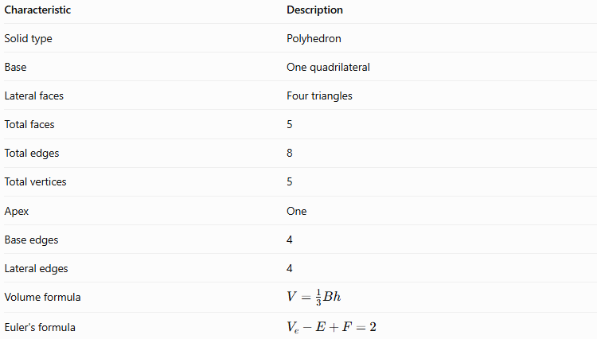
Characteristic | Description
Solid type | Polyhedron
Base | One quadrilateral
Lateral faces | Four triangles
Total faces | 5
Total edges | 8
Total vertices | 5
Apex | One
Base edges | 4
Lateral edges | 4
Volume formula | $$V=\frac{1}{3}Bh$$
Euler's formula | $$V_{e}-E+F=2$$
Here, $V_{e}$ represents the number of vertices, while $V$ represents volume.

Geometric Representation
# Source: AI Source: Provided by: [Data Path: Persons Table -> ID Column: 1, Name_En Column: Motasem Essam] -> From: [ChatGPT] on [7/25/2026]
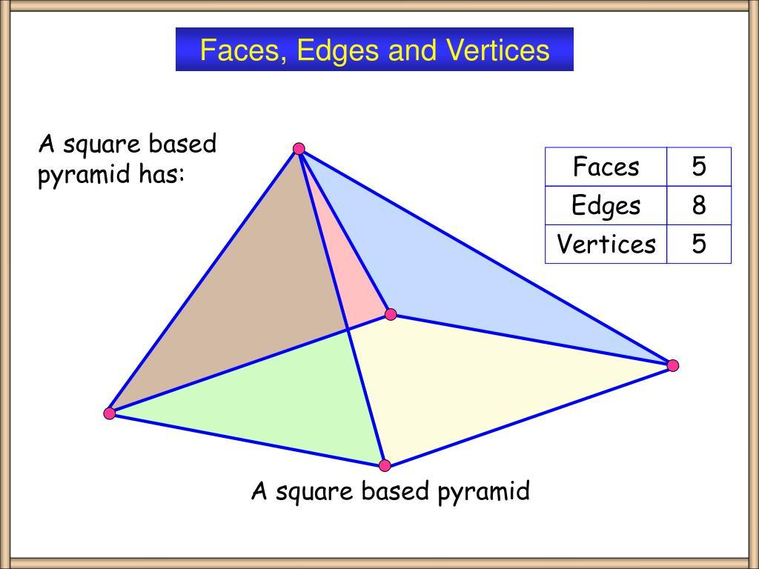
Consider a quadrilateral pyramid with base $ABCD$ and apex $E$.
Its components are:
- Base face $ABCD$: The four-sided polygon at the bottom.
- Lateral face $ABE$: One triangular side face.
- Lateral face $BCE$: The second triangular side face.
- Lateral face $CDE$: The third triangular side face.
- Lateral face $DAE$: The fourth triangular side face.
- Apex $E$: The vertex opposite the base.
Edges and vertices
The eight edges are divided into two groups.
- Base edges: $AB$, $BC$, $CD$, and $DA$.
- Lateral edges: $AE$, $BE$, $CE$, and $DE$.
The five vertices are $A$, $B$, $C$, $D$, and $E$.

Mathematical Properties and Formulas
# Source: AI Source: Provided by: [Data Path: Persons Table -> ID Column: 1, Name_En Column: Motasem Essam] -> From: [ChatGPT] on [7/25/2026]
Let:
- $B$ = area of the quadrilateral base
- $h$ = perpendicular height of the pyramid
- $A_{L}$ = lateral surface area
- $A_{T}$ = total surface area
- $V$ = volume
- $p$ = perimeter of the base

Number of faces, edges, and vertices
# Source: AI Source: Provided by: [Data Path: Persons Table -> ID Column: 1, Name_En Column: Motasem Essam] -> From: [ChatGPT] on [7/25/2026]
For a pyramid with an $n$-sided base:
$$F=n+1, E=2n, V_{e}=n+1$$
For a quadrilateral pyramid, $n=4$:
$$F=4+1=\boxed{5}$$
$$E=2\left(4\right)=\boxed{8}$$
$$V_{e}=4+1=\boxed{5}$$

Base area
# Source: AI Source: Provided by: [Data Path: Persons Table -> ID Column: 1, Name_En Column: Motasem Essam] -> From: [ChatGPT] on [7/25/2026]
The base area depends on the type of quadrilateral.
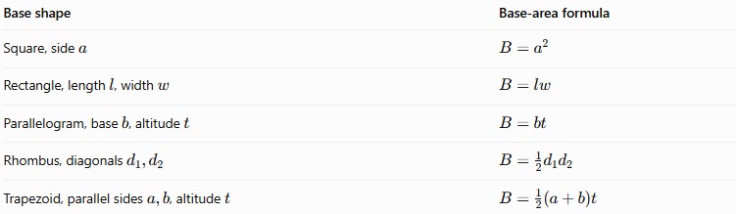
Base shape | Base-area formula
Square, side $a$ | $$B=a^{2}$$
Rectangle, length $l$, width $w$ | $$B=lw$$
Parallelogram, base $b$, altitude $t$ | $$B=bt$$
Rhombus, diagonals $d_{1},d_{2}$ | $$B=\frac{1}{2}d_{2}d_{2}$$
Trapezoid, parallel sides $a,b$, altitude $t$ | $$B=\frac{1}{2}\left(a+b\right)t$$
The height used in a base-area formula is the altitude of that quadrilateral. It is not necessarily the pyramid's perpendicular height.

Volume
# Source: AI Source: Provided by: [Data Path: Persons Table -> ID Column: 1, Name_En Column: Motasem Essam] -> From: [ChatGPT] on [7/25/2026]
The volume of any pyramid is one-third of the product of its base area and perpendicular height:
$$\boxed{V=\frac{13}{B}h}$$
For a square-base pyramid with side length $a$:
$$\boxed{V={\frac{13}{a}}^{2}h}$$
For a rectangular-base pyramid:
$$\boxed{V=\frac{13}{l}wh}$$

Lateral surface area
# Source: AI Source: Provided by: [Data Path: Persons Table -> ID Column: 1, Name_En Column: Motasem Essam] -> From: [ChatGPT] on [7/25/2026]
The lateral surface area is the sum of the four triangular side-face areas:
$$\boxed{A_{L}=A_{1}+A_{2}+A_{3}+A_{4}}$$
For each triangular face:
$$A_{i}={\frac{12}{b}}_{i}t_{i}$$
where $b_{i}$ is the chosen side of the base and $t_{i}$ is the perpendicular altitude within that triangular face.
For a regular square pyramid, all four lateral faces are congruent isosceles triangles. If $p$ is the base perimeter and $l$ is the slant height:
$$\boxed{A_{L}=\frac{12}{p}l}$$
This shortcut applies to a regular square pyramid, not to every quadrilateral pyramid.

Total surface area
# Source: AI Source: Provided by: [Data Path: Persons Table -> ID Column: 1, Name_En Column: Motasem Essam] -> From: [ChatGPT] on [7/25/2026]
The total surface area includes the base and all four lateral faces:
$$\boxed{A_{T}=B+A_{L}}$$
For a regular square pyramid:
$$\boxed{A_{T}=a^{2}+2al}$$
Here, $a$ is the square's side length and $l$ is the slant height of a lateral face.

Euler's formula
# Source: AI Source: Provided by: [Data Path: Persons Table -> ID Column: 1, Name_En Column: Motasem Essam] -> From: [ChatGPT] on [7/25/2026]
For a convex quadrilateral pyramid:
$$V_{e}-E+F=2$$
Substituting the values:
$$5-8+5=\boxed{2}$$
Therefore, the quadrilateral pyramid satisfies Euler's formula.

Types of Quadrilateral Pyramids by Base Shape

Square-Base Pyramid
# Source: AI Source: Provided by: [Data Path: Persons Table -> ID Column: 1, Name_En Column: Motasem Essam] -> From: [ChatGPT] on [7/25/2026]
Has a square base and four triangular lateral faces. A regular square pyramid has its apex directly above the center of the base, with equal lateral edges.
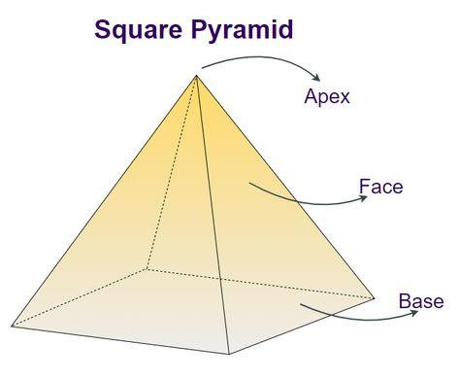

Rectangular-Base Pyramid
# Source: AI Source: Provided by: [Data Path: Persons Table -> ID Column: 1, Name_En Column: Motasem Essam] -> From: [ChatGPT] on [7/25/2026]
Has a rectangular base. Its lateral triangles may differ in size, depending on the apex's position and the rectangle's dimensions.
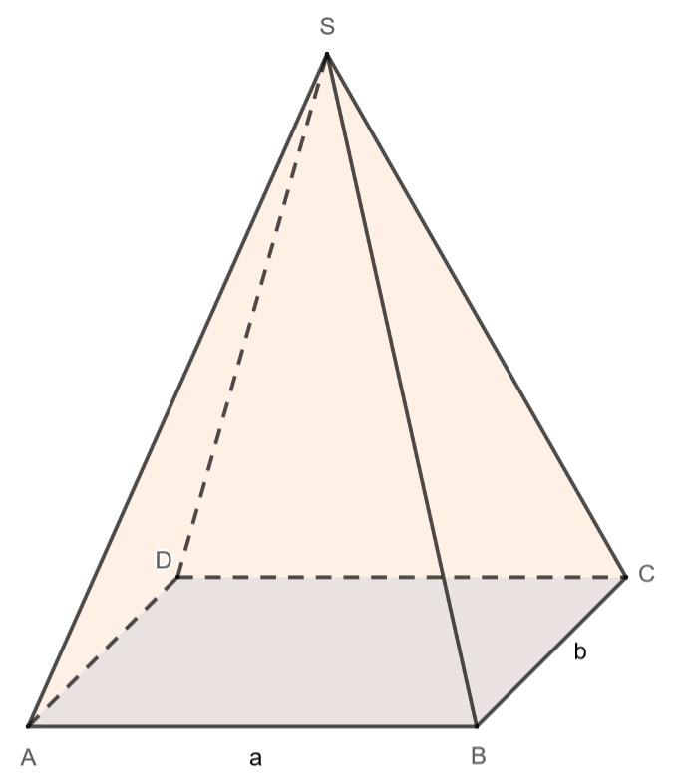

Rhombus-Base Pyramid
# Source: AI Source: Provided by: [Data Path: Persons Table -> ID Column: 1, Name_En Column: Motasem Essam] -> From: [ChatGPT] on [7/25/2026]
Has a rhombus as its base, with four equal base edges. The lateral faces are triangular.
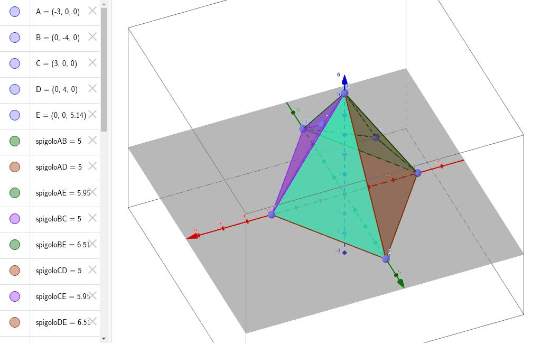

Parallelogram-Base Pyramid
# Source: AI Source: Provided by: [Data Path: Persons Table -> ID Column: 1, Name_En Column: Motasem Essam] -> From: [ChatGPT] on [7/25/2026]
Has a parallelogram as its base. Opposite base edges are parallel and equal in length.
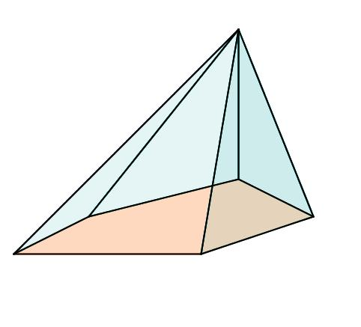

Trapezoidal-Base Pyramid
# Source: AI Source: Provided by: [Data Path: Persons Table -> ID Column: 1, Name_En Column: Motasem Essam] -> From: [ChatGPT] on [7/25/2026]
Has a trapezoid as its base. The trapezoid has a pair of parallel sides under the common inclusive definition.
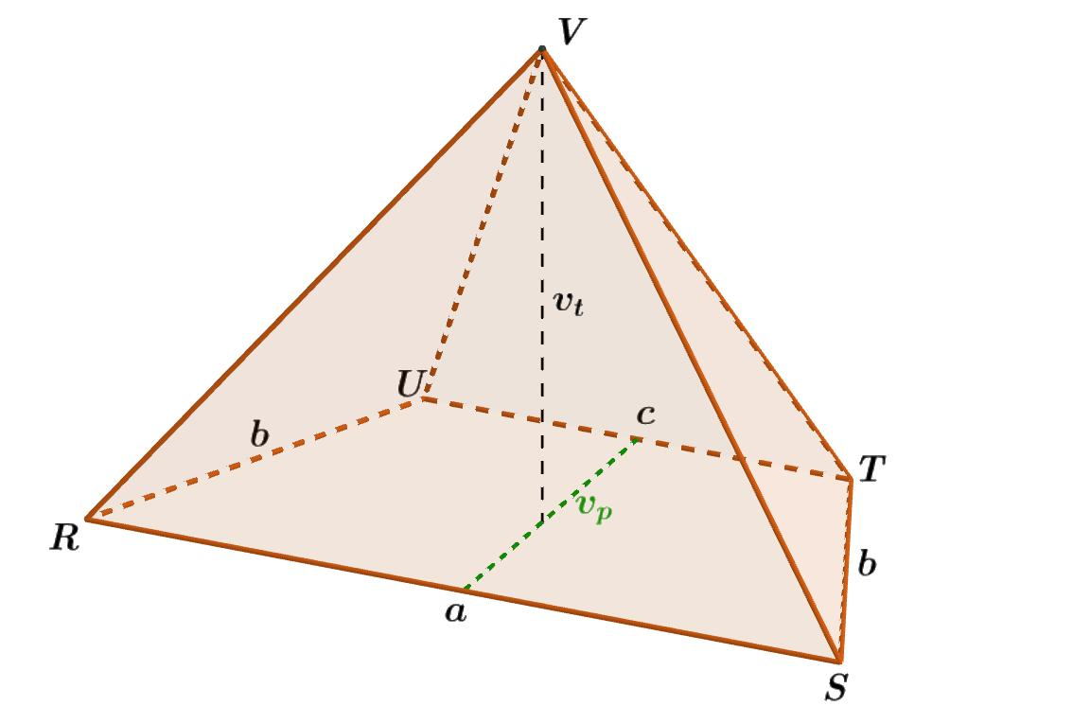

Types by Spatial Orientation

Right Quadrilateral Pyramid
# Source: AI Source: Provided by: [Data Path: Persons Table -> ID Column: 1, Name_En Column: Motasem Essam] -> From: [ChatGPT] on [7/25/2026]
The apex lies directly above the center of the base. The perpendicular height meets the base at its center.
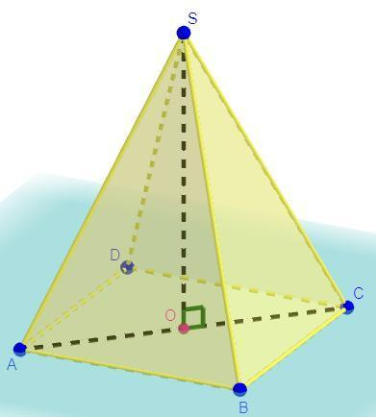

Oblique Quadrilateral Pyramid
# Source: AI Source: Provided by: [Data Path: Persons Table -> ID Column: 1, Name_En Column: Motasem Essam] -> From: [ChatGPT] on [7/25/2026]
The apex is offset from the center of the base, giving the pyramid a leaning appearance.
A right quadrilateral pyramid does not necessarily have a square base. The term right describes the position of the apex relative to the base, not the shape of the base.
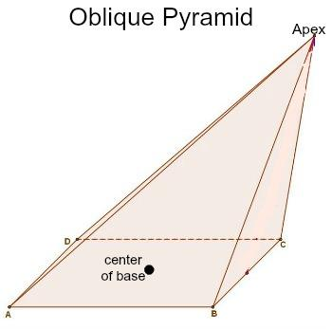

Worked Examples
# Source: AI Source: Provided by: [Data Path: Persons Table -> ID Column: 1, Name_En Column: Motasem Essam] -> From: [ChatGPT] on [7/25/2026]
Example 1: Counting faces, edges, and vertices
Problem: Find the number of faces, edges, and vertices of a quadrilateral pyramid.
Solution:
- Faces: $4+1=\boxed{5}$
- Edges: $2\left(4\right)=\boxed{8}$
- Vertices: $4+1=\boxed{5}$
Answer: 5 faces, 8 edges, and 5 vertices.
Example 2: Calculating volume
Problem: A quadrilateral pyramid has a base area of $36{\text{ cm}}^{2}$ and a perpendicular height of $12\text{ cm}$. Find its volume.
Solution:
$$V=\frac{1}{3}Bh$$
$$V=\frac{1}{3}\left(36\right)\left(12\right)$$
$$\boxed{V=144{\text{ cm}}^{3}}$$
Answer: The volume is $144{\text{ cm}}^{3}$.
Example 3: Calculating the volume of a square-base pyramid
Problem: A square-base pyramid has a base side length of $6\text{ cm}$ and a perpendicular height of $10\text{ cm}$. Find its volume.
Solution:
First, calculate the base area:
$$B=6^{2}=36{\text{ cm}}^{2}$$
Then calculate the volume:
$$V=\frac{1}{3}\left(36\right)\left(10\right)$$
$$\boxed{V=120{\text{ cm}}^{3}}$$
Answer: The volume is $120{\text{ cm}}^{3}$.
Example 4: Calculating total surface area
Problem: A quadrilateral pyramid has a base area of $30{\text{ cm}}^{2}$. Its four triangular lateral faces have areas of $12$, $14$, $13$, and $15{\text{ cm}}^{2}$. Find the total surface area.
Solution:
Calculate the lateral surface area:
$$A_{L}=12+14+13+15=54{\text{ cm}}^{2}$$
Add the base area:
$$A_{T}=B+A_{L}$$
$$A_{T}=30+54$$
$$\boxed{A_{T}=84{\text{ cm}}^{2}}$$
Answer: The total surface area is $84{\text{ cm}}^{2}$.
Example 5: Verifying Euler's formula
Problem: Verify Euler's formula for a quadrilateral pyramid.
Solution:
$$V_{e}-E+F=5-8+5$$
$$\boxed{2=2}$$
Answer: Euler's formula is satisfied.

Quadrilateral Pyramid vs. Quadrilateral Prism

Quadrilateral Pyramid
# Source: AI Source: Provided by: [Data Path: Persons Table -> ID Column: 1, Name_En Column: Motasem Essam] -> From: [ChatGPT] on [7/25/2026]
- One quadrilateral base.
- One apex.
- 5 faces.
- 8 edges.
- 5 vertices.
- $V=\frac{1}{3}Bh$.
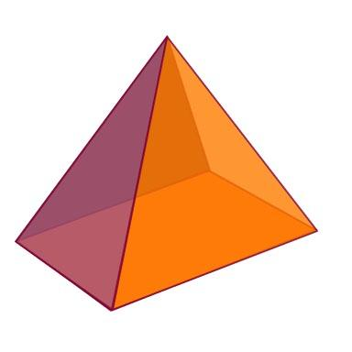

Quadrilateral Prism
# Source: AI Source: Provided by: [Data Path: Persons Table -> ID Column: 1, Name_En Column: Motasem Essam] -> From: [ChatGPT] on [7/25/2026]
- Two congruent parallel quadrilateral bases.
- No single apex.
- 6 faces.
- 12 edges.
- 8 vertices.
- $V=Bh$.
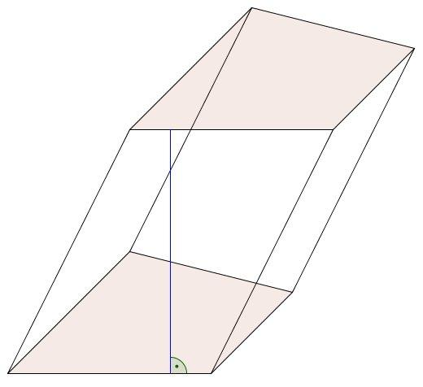
The key difference is that a pyramid tapers to one apex, while a prism connects two congruent, parallel bases.

Constructing Quadrilateral Pyramid in Solid Geometry

Instruments Used
# Source: AI Source: Provided by: [Data Path: Persons Table -> ID Column: 1, Name_En Column: Motasem Essam] -> From: [ChatGPT] on [7/25/2026]
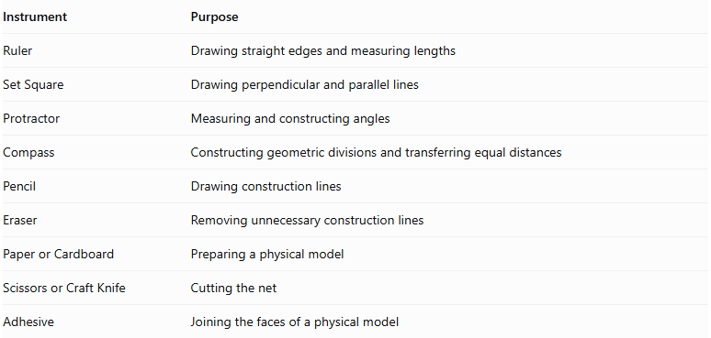
Instrument | Purpose
Ruler | Drawing straight edges and measuring lengths
Set Square | Drawing perpendicular and parallel lines
Protractor | Measuring and constructing angles
Compass | Constructing geometric divisions and transferring equal distances
Pencil | Drawing construction lines
Eraser | Removing unnecessary construction lines
Paper or Cardboard | Preparing a physical model
Scissors or Craft Knife | Cutting the net
Adhesive | Joining the faces of a physical model

Construction Procedures

A. Base-Based Construction
# Source: AI Source: Provided by: [Data Path: Persons Table -> ID Column: 1, Name_En Column: Motasem Essam] -> From: [ChatGPT] on [7/25/2026]
- Draw a quadrilateral base using a ruler and appropriate geometric instruments.
- Determine the position of the apex above or away from the base.
- Mark the apex.
- Connect the apex to the four vertices of the quadrilateral base.
- Complete the four triangular lateral faces.
- Verify that all edges are properly connected.
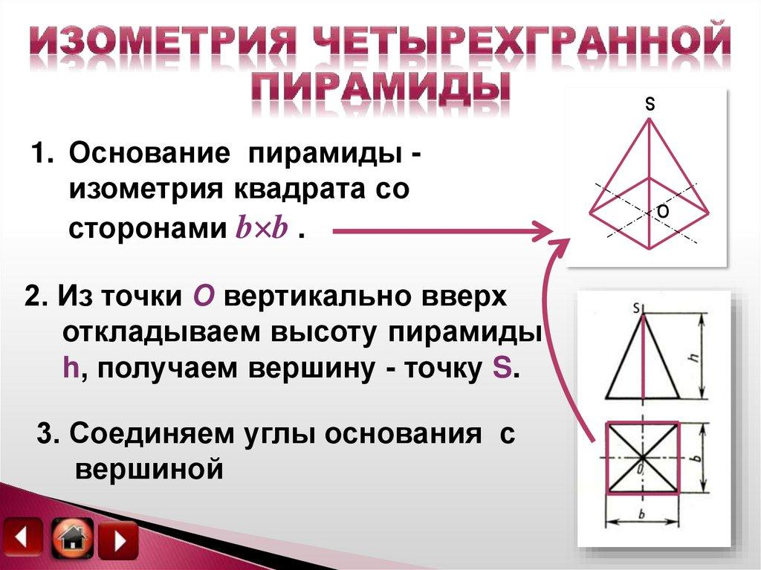

B. Apex-Based Construction
# Source: AI Source: Provided by: [Data Path: Persons Table -> ID Column: 1, Name_En Column: Motasem Essam] -> From: [ChatGPT] on [7/25/2026]
- Mark a point representing the apex.
- Construct four base vertices at the required positions.
- Connect the four base vertices to form a quadrilateral.
- Connect the apex to each of the four base vertices.
- Complete the five faces.

C. Vertex-Connection Construction
# Source: AI Source: Provided by: [Data Path: Persons Table -> ID Column: 1, Name_En Column: Motasem Essam] -> From: [ChatGPT] on [7/25/2026]
- Identify the four vertices of the quadrilateral base.
- Identify the apex.
- Connect the apex to each of the four base vertices.
- Verify that four lateral edges are formed.
- Confirm that the solid has five vertices in total.

D. Edge-Based Construction
# Source: AI Source: Provided by: [Data Path: Persons Table -> ID Column: 1, Name_En Column: Motasem Essam] -> From: [ChatGPT] on [7/25/2026]
- Construct the four edges of the quadrilateral base.
- Determine the lengths of the four lateral edges.
- Construct the lateral edges from the base vertices toward the apex.
- Join their upper endpoints at the common apex.
- Complete the four triangular lateral faces.

E. Face-Based Construction
# Source: AI Source: Provided by: [Data Path: Persons Table -> ID Column: 1, Name_En Column: Motasem Essam] -> From: [ChatGPT] on [7/25/2026]
- Construct the quadrilateral base.
- Construct the four triangular lateral faces.
- Connect each lateral face to its corresponding base edge.
- Join the lateral faces along their common lateral edges.
- Verify that the resulting solid is closed.

F. Net-Based Construction
# Source: AI Source: Provided by: [Data Path: Persons Table -> ID Column: 1, Name_En Column: Motasem Essam] -> From: [ChatGPT] on [7/25/2026]
The net of a quadrilateral pyramid consists of:
- One quadrilateral base.
- Four triangular lateral faces.
- Optional tabs for joining the faces.
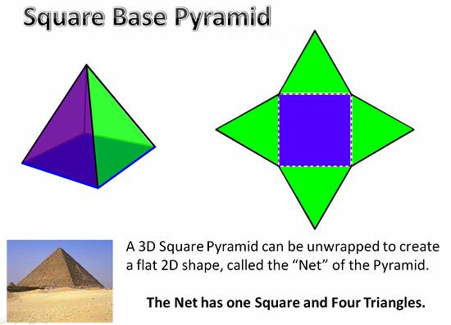

G. Physical Model Construction
# Source: AI Source: Provided by: [Data Path: Persons Table -> ID Column: 1, Name_En Column: Motasem Essam] -> From: [ChatGPT] on [7/25/2026]
- Draw the complete net on cardboard.
- Include joining tabs around selected edges.
- Cut out the net.
- Fold along the boundaries of the five faces.
- Join the four triangular lateral faces together.
- Attach the quadrilateral base.
- Secure the edges using adhesive.

Real-World Applications
# Source: AI Source: Provided by: [Data Path: Persons Table -> ID Column: 1, Name_En Column: Motasem Essam] -> From: [ChatGPT] on [7/25/2026]
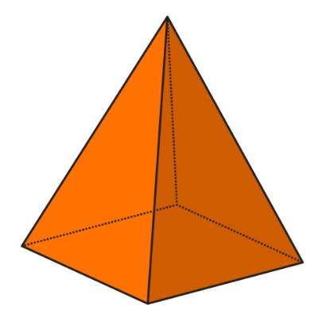
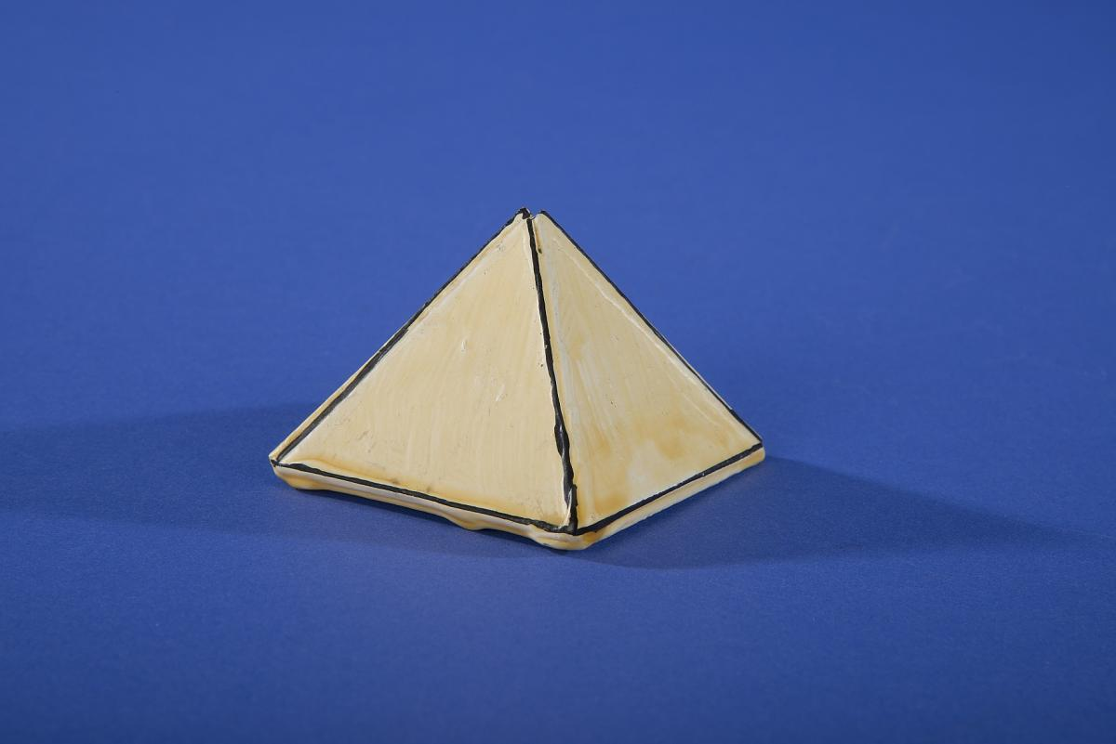
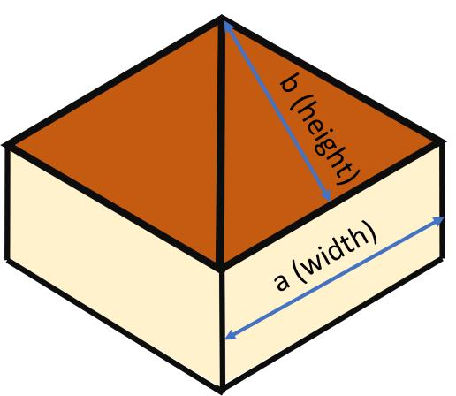
Quadrilateral pyramids are useful in:
- Architecture: Pyramid-shaped roofs and decorative structures.
- Engineering: Geometric models of tapered structural components.
- Mathematics education: Studying polyhedra, surface area, volume, and Euler's formula.
- Computer graphics: Building and rendering polygon-based 3D models.
- Design and sculpture: Creating four-sided tapered forms.
These are examples of applications of pyramid geometry; an actual object may have additional features that prevent it from being an exact geometric pyramid.

Key Points
# Source: AI Source: Provided by: [Data Path: Persons Table -> ID Column: 1, Name_En Column: Motasem Essam] -> From: [ChatGPT] on [7/25/2026]
- A quadrilateral pyramid has one four-sided base and four triangular lateral faces.
- It has 5 faces, 8 edges, and 5 vertices.
- Its apex is the vertex where all four lateral faces meet.
- Its volume is $V=\frac{1}{3}Bh$.
- Its total surface area is $A_{T}=B+A_{L}$.
- The base may be a square, rectangle, rhombus, parallelogram, or trapezoid.
- A right pyramid has its apex directly above the center of its base.
- A regular square pyramid is a special case with a square base and four congruent lateral faces.
- A convex quadrilateral pyramid satisfies Euler's formula: $V_{e}-E+F=2$.

Conclusion
# Source: AI Source: Provided by: [Data Path: Persons Table -> ID Column: 1, Name_En Column: Motasem Essam] -> From: [ChatGPT] on [7/25/2026]
A quadrilateral pyramid is a polyhedron with one quadrilateral base and four triangular lateral faces meeting at a single apex. Its base shape determines whether it is a square-base, rectangular-base, rhombus-base, parallelogram-base, or trapezoidal-base pyramid.
Its essential properties remain the same regardless of the base shape: it has 5 faces, 8 edges, and 5 vertices, and its volume is one-third of the product of the base area and perpendicular height. Understanding this solid provides a foundation for studying pyramids with polygonal bases containing more sides.

